SIMATS ENGINEERING (SAVEETHA SCHOOL OF ENGINEERING)
Department of Computer Science and Engineering
CO2 ASSESSMENT TOOL 2 – Architecture Design Assignment

Course Code: | CSA1008 | Course Title: | Software Engineering
CO Assessed: | CO2 | Assessment: | Assessment Tool 2 – Architecture Design Assignment
Weightage: | 20% | Total Marks: | 25
CO2 Statement: | Perform detailed requirements analysis, design scalable architectures, and prioritize features with a focus on cross-disciplinary skills
Student Name: | ARTHI A | Reg. No.: | 192525152
Date: | 08.08.2026 | Duration: | 60 minutes

Code of Conduct
I ARTHI A (Name / Reg No) certify that this submission is my original work and that I have adhered to the guidelines specified for this assessment. I understand that any violation of academic integrity rules will result in disciplinary action.
Signature of the Student: 
Annexure A – Architecture Design Assignment
Instructions to Students:
Each student will be assigned an individual software project problem statement. Based on the assigned problem, analyze the system requirements and design an appropriate software architecture by applying software engineering principles. Your submission should demonstrate your ability to select, justify, and evaluate a suitable architectural style.

Question
Based on Case Study 36 – SDG 9: Smart Construction Project Management System. Construction companies manage multiple projects simultaneously using spreadsheets and manual reporting. Delays in material procurement, poor communication, and lack of progress tracking often result in cost overruns. The company plans to adopt a centralized software solution for project planning, resource management, and progress monitoring. As a software engineer, analyze the above problem and propose a suitable software engineering solution, perform an Architecture Design Analysis and prepare an architecture design report by answering the following questions:

1. Analyze System Requirements
- Study the given problem statement and identify the system objectives.
- Analyze the functional and non-functional requirements that influence the software architecture.
- Identify key quality attributes such as scalability, maintainability, reliability, availability, performance, and security.

2. Select a Suitable Software Architecture
- Select an appropriate architectural style for the proposed system (e.g., Layered Architecture, Client-Server, MVC, Microservices, Event-Driven, Service-Oriented Architecture, Serverless, or Hybrid Architecture).
- Justify why the selected architecture is the most suitable for the given problem.

3. Draw the Software Architecture Diagram
- Design a clear architecture diagram illustrating the overall structure of the proposed system.
- Include all major layers/components, databases, external systems, APIs, and communication mechanisms.
- Use appropriate software architecture notations and labels.

4. Explain Components and Their Interactions
- Describe the purpose and responsibilities of each architectural component.
- Explain how the components communicate and exchange data.
- Illustrate the overall workflow of the system.

5. Discuss Quality Attributes
Evaluate how the proposed architecture addresses the following aspects:
- Scalability
- Security
- Performance
- Reliability
- Maintainability
- Availability

6. Justify Architectural Decisions
- Explain the rationale behind your architectural choices.
- Discuss the trade-offs considered while selecting the architecture.
- Explain how the chosen architecture supports future enhancements, system integration, and long-term maintainability.
Rubrics for Calculation
Evaluation Criteria | Excellent (4 Marks) | Good (3 Marks) | Satisfactory (2 Marks) | Needs Improvement (1 Mark)
System Requirement Analysis | Thoroughly analyzes the problem statement, accurately identifies functional and non-functional requirements, and clearly explains quality attributes influencing the architecture. | Analyzes most requirements with minor omissions or limited explanation. | Identifies only basic requirements with partial analysis. | Requirement analysis is incomplete, inaccurate, or lacks clarity.
Selection of Software Architecture | Selects the most appropriate architectural style with strong technical justification aligned to system requirements. | Selects a suitable architecture with reasonable justification. | Architecture is partially suitable with limited justification. | Inappropriate architecture selected or justification is missing.
Architecture Diagram and Component Design | Produces a clear, complete, and well-structured architecture diagram with all major components, interfaces, and interactions accurately represented. | Diagram is mostly complete with minor omissions or notation issues. | Diagram includes only essential components and lacks sufficient detail. | Diagram is incomplete, unclear, or technically incorrect.
Component Interaction and Quality Attribute Analysis | Clearly explains component responsibilities, interactions, and thoroughly discusses scalability, security, performance, reliability, maintainability, and availability. | Explains most components and quality attributes with minor gaps. | Provides limited explanation of interactions and addresses only some quality attributes. | Component interactions and quality attributes are poorly explained or missing.
Architectural Justification and Technical Presentation | Provides strong justification for architectural decisions, discusses trade-offs and future enhancements, and presents a well-organized, professional report. | Provides adequate justification with minor gaps; report is well organized. | Limited justification with minimal discussion of trade-offs or future scope; report needs improvement. | Justification is weak or absent; report lacks organization and technical clarity.

Criteria | Mark
System Requirement Analysis | /5
Selection of Software Architecture | /5
Architecture Diagram and Component Design | /5
Component Interaction and Quality Attribute Analysis | /5
Architectural Justification and Technical Presentation | /5
TOTAL | /5

Case Study 36 – SDG 9: Smart Construction Project Management System

Construction companies manage multiple projects simultaneously using spreadsheets and manual reporting. Delays in material procurement, poor communication, and lack of progress tracking often result in cost overruns. The company plans to adopt a centralized software solution for project planning, resource management, and progress monitoring.

As a software engineer, analyze the above problem and propose a suitable software engineering solution.

1. System Requirement Analysis
1.1 Scenario Understanding
Construction companies today manage multiple simultaneous projects using spreadsheets and manual, phone/email-based reporting. This creates a structural information gap: site-level events (progress, material shortages, schedule slippage) are known on-site well before they are known in the office, and are known in the office well before they are known to the client. Each handoff between these three points (site → office → client) currently happens manually, introducing delay, data loss, and inconsistency. The proposed Smart Construction Project Management System closes this gap by making site-level events visible to every relevant stakeholder within minutes rather than days, through a single centralized platform with role-specific interfaces.

1.2 System Objectives
- Centralize project planning, resource/material management, and progress monitoring into one authoritative platform, replacing fragmented spreadsheets and informal communication channels
- Reduce the field-to-office information lag from days to minutes, so that project managers act on current, not stale, data
- Introduce a structured, auditable approval chain for material requisitions and milestone verification, replacing informal phone/email approvals
- Give clients transparent, verifiable visibility into milestone progress, tying payment approval directly to verified work rather than self-reported claims
- Build a foundation that can scale from a single project team to a multi-project, multi-site portfolio without architectural rework
1.3 Functional Requirements Influencing the Architecture
Of the system's 12 functional requirements (detailed in the accompanying SRS), the following most directly shape architectural decisions:
Requirement | Architectural implication
FR-1 to FR-3 (Site Engineer logging, task updates, requisitions) | Requires a lightweight, offline-tolerant mobile client and a write path optimized for frequent, small updates from the field
FR-4 (PM consolidated dashboard) | Requires an aggregation/read path capable of summarizing data across multiple projects without overloading the database with repeated heavy queries
FR-5, FR-7 (Requisition and milestone approval) | Requires a business logic layer that enforces sequential, stateful workflows (Pending → Approved/Rejected) consistently regardless of which client initiated the action
FR-8, FR-9 (Purchase order conversion and tracking) | Requires a clear boundary between the Procurement domain and the core Progress/Approval domain, while still sharing the same underlying data
FR-10, FR-11 (Client portal, payment approval) | Requires strict data isolation — a client-facing layer must expose only that client's verified data, never another client's raw internal data
FR-12 (Notifications) | Requires a mechanism that reacts to state changes without blocking the primary request path — naturally suited to an event-style trigger rather than a synchronous call

1.4 Non-Functional Requirements Influencing the Architecture
NFR | Requirement | Why it constrains the architecture
NFR-1 | Progress updates visible within 5 minutes | Rules out purely batch/offline sync designs; favors a near-real-time request/response or short-interval sync path
NFR-3, NFR-4 | Role-based access control, authenticated approvals | Requires a centralized authorization checkpoint rather than access logic duplicated across four separate client apps
NFR-5 | 99.5% uptime | Favors a design where a failure in one layer (e.g. notification delivery) cannot bring down core workflows (e.g. progress logging)
NFR-6 | Scalability across multiple concurrent projects | Favors horizontally scalable, stateless application-layer components over a monolith with in-memory session state
NFR-7 | Independent module maintainability | Directly motivates separating presentation, business logic, and data concerns into distinct layers
NFR-8 | Offline resilience for field use | Requires the mobile client to support local queuing and later synchronization rather than assuming a permanent connection

1.5 Quality Attributes Prioritized
Given the problem domain, the following quality attributes were ranked by criticality and directly informed the architectural style selected in Section 2:
Rank | Attribute | Justification
1 | Reliability | Approval and payment workflows involve money and contractual milestones — data loss or duplicated approvals are unacceptable
2 | Maintainability | Four distinct client applications must evolve independently over the system's lifetime without destabilizing shared business rules
3 | Availability | Field connectivity is inherently unreliable; the system must degrade gracefully rather than block work
4 | Scalability | The platform is intended to grow from one project to a full portfolio of concurrent projects
5 | Security | Role isolation (Site Engineer vs Client vs Admin) must be enforced consistently, since a breach of client data isolation would be a serious trust failure
6 | Performance | A 5-minute propagation target is achievable without extreme low-latency engineering, making it the least architecturally demanding attribute here

2. Selection of Software Architecture
2.1 Architectural Styles Considered
Style | Fit for this system
Monolithic (single-tier) | Rejected — mixes UI, logic, and data concerns in one deployable unit, directly violating NFR-7 (independent maintainability) and making 4 separate client types harder to support cleanly
Microservices | Rejected for this phase — offers strong independent scalability, but the operational overhead (service discovery, distributed transactions, inter-service network calls) is disproportionate to current team size and project scope; reconsidered as a future evolution path
Pure Event-Driven Architecture | Rejected as the primary style — excellent for loosely coupled, high-throughput systems, but core approval workflows here are inherently sequential and require strong consistency, which a fully asynchronous event mesh makes harder to reason about and test
Service-Oriented Architecture (SOA) | Rejected — SOA's heavyweight service-bus/enterprise integration pattern is over-engineered for a single-organization system with four client types and one backend
Layered (N-Tier) Architecture + Client-Server | Selected — see justification below

2.2 Selected Architecture
Layered (N-Tier) Architecture, combined with a Client-Server communication model, and a small event-driven element for notifications. The system is structured into five layers ,Presentation, API Gateway, Business Logic, Data Access, and Database with an external Notification Service loosely coupled to the Business Logic layer via asynchronous events.

2.3 Justification
- Direct structural fit: the problem domain already separates naturally into "who is looking at the data" (4 client types), "what rules govern the data" (approvals, requisitions, milestones), and "where the data lives" (one shared database), Layered Architecture is the most literal, low-risk mapping of that structure onto software components.
- Client-Server communication over REST APIs is the natural fit for FR-4, FR-10 and similar requirements where each client (mobile, dashboard, portal, queue) independently requests and submits data to one shared backend, rather than communicating peer-to-peer.
- Compared to Microservices, Layered Architecture achieves the same separation-of-concerns benefit for maintainability (NFR-7) without requiring distributed-systems infrastructure the team does not yet need — this keeps initial build time and operational risk low while still leaving a clear extraction path later (see Section 6).
- Compared to pure Event-Driven Architecture, a layered/transactional core gives strong guarantees for the money- and contract-adjacent workflows (requisition approval, milestone verification, payment release) where ordering and consistency genuinely matter, while still permitting an event-driven notification component where asynchronous delivery is actually an advantage rather than a risk.
- The approach is deliberately hybrid rather than dogmatic: strict layering is used where predictability is critical (the approval chain), and a lightweight event trigger is used where it is not (alerting a user that something happened) — this matches architecture decisions to the actual risk profile of each requirement rather than forcing one pattern everywhere.
3. Software Architecture Diagram
3.1 Diagram Structure (top to bottom)
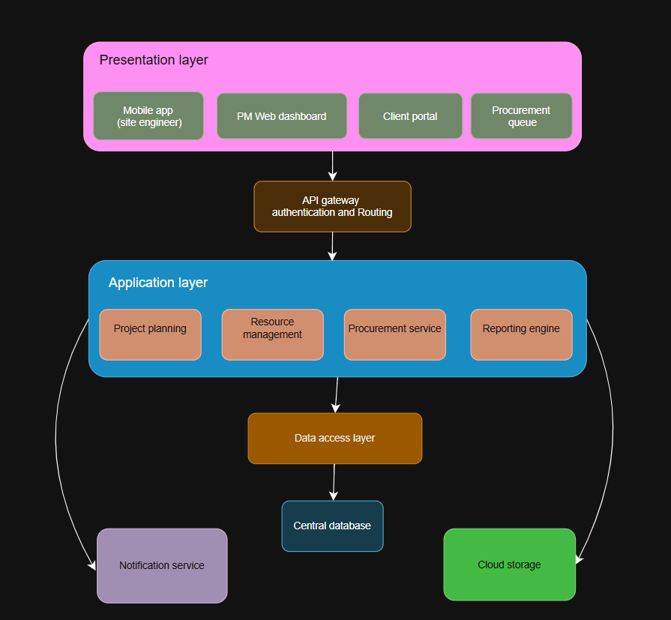
- Presentation Layer — Mobile App (Site Engineer), Web Dashboard (Project Manager), Client Portal, Procurement Queue — four independent client applications, each communicating only with the API Gateway, never directly with each other or the database
- API Gateway Layer — single entry point for all client requests; performs authentication, role validation, and routes each request to the correct Business Logic module
- Business Logic Layer — three cohesive modules: Progress Management (FR-1, FR-2), Approval Workflow Engine (FR-5, FR-7, FR-11), and Procurement Logic (FR-8, FR-9); each module owns its own rules but shares the Data Access layer
- Data Access Layer — a repository/ORM abstraction so that Business Logic never issues raw queries directly, keeping the database technology swappable
- Database Layer — single central relational database holding users, projects, progress logs, requisitions, purchase orders, and milestones
- External Component — Notification Service, connected to the Business Logic layer via a dashed, one-directional event arrow (not a request/response call), representing its asynchronous, fire-and-forget nature

3.2 Notation Guidance
- Use rounded rectangles for each layer/component, sized to comfortably fit its label
- Use solid arrows with arrowheads for synchronous, top-down request/response calls between layers
- Use a dashed arrow for the asynchronous connection from Business Logic to the Notification Service, to visually distinguish it from the synchronous layer calls
- Label each arrow only where the direction/protocol isn't obvious (e.g., "HTTPS/REST" between Presentation and API Gateway)
- Keep the diagram strictly top-to-bottom for the five core layers — do not draw them as a cycle or mesh, since the whole point of a layered diagram is to show one-directional dependency

4. Components and Their Interactions
4.1 Component Responsibilities
Component | Responsibility
Presentation Layer | Renders role-specific UI; captures and validates user input at the field level; sends authenticated requests to the API Gateway; renders returned data; queues writes locally when offline (mobile only)
API Gateway Layer | Authenticates every incoming request (token validation), checks the caller's role against the requested action, routes valid requests to the correct Business Logic module, and returns a uniform error format for rejected requests
Business Logic Layer — Progress Management | Validates and stores progress log submissions; updates task status; computes schedule variance for the PM dashboard
Business Logic Layer — Approval Workflow Engine | Enforces the requisition and milestone state machine (Pending → Approved/Rejected → Verified); prevents invalid transitions (e.g., approving an already-rejected requisition); emits events on state changes
Business Logic Layer — Procurement Logic | Converts approved requisitions into purchase orders; tracks and updates delivery status; links POs back to their originating requisition for traceability
Data Access Layer | Translates Business Logic calls into database operations via a repository pattern, isolating SQL/query details from business rules
Database Layer | Persists all system entities with referential integrity — e.g., a purchase order cannot exist without a linked, approved requisition
Notification Service | Subscribes to events emitted by the Business Logic layer and delivers push/email/in-app alerts asynchronously, decoupled from the main request/response cycle

4.2 Communication Protocol
All Presentation-layer clients communicate with the backend exclusively over HTTPS using RESTful JSON APIs exposed by the API Gateway. This is a strict client-server model: no client ever queries the database directly or calls another client. Internally, the API Gateway calls Business Logic modules via direct in-process method calls (since they run within the same backend deployment in this phase), and Business Logic calls the Data Access layer the same way. The one exception is the Business Logic → Notification Service link, which is asynchronous (an internal event/message rather than a direct call), so that a slow or failed notification delivery can never delay or block a user-facing approval action.

4.3 Example Workflow — Material Requisition Approval End to End
- 1. Site Engineer submits a requisition via the mobile app → request sent over HTTPS to the API Gateway
- 2. API Gateway authenticates the Site Engineer's token and role, then routes the request to the Approval Workflow Engine within Business Logic
- 3. Approval Workflow Engine validates the payload (material, quantity, urgency) and creates a new requisition record with status "Pending" via the Data Access layer
- 4. Project Manager opens the Web Dashboard; the API Gateway retrieves all "Pending" requisitions for the PM's assigned projects
- 5. PM approves the requisition; the request flows back through the same path — API Gateway → Approval Workflow Engine — which validates that the transition Pending → Approved is legal and persists it
- 6. Approval Workflow Engine emits an "requisition approved" event; the Notification Service picks this up independently and alerts both the Site Engineer and the Procurement Officer
- 7. Procurement Officer opens the Procurement Queue; Procurement Logic exposes the newly approved requisition for conversion into a purchase order (FR-8), completing the workflow's first cycle

5. Quality Attribute Discussion
Attribute | How the architecture addresses it
Scalability | Because the API Gateway and Business Logic layer are stateless (no session data held in memory between requests), multiple instances of these layers can run behind a load balancer and scale horizontally as the number of concurrent projects and users grows, without any change to the Presentation or Database layers.
Security | Authentication and role-based access control are centralized at the single API Gateway entry point, so every one of the four client types is subject to identical, consistently enforced rules — eliminating the risk of one client (e.g., a future supplier app) implementing weaker access checks than the others.
Performance | The dedicated Data Access layer creates a single place to introduce caching (e.g., caching a Project Manager's dashboard query for a short interval) without modifying Business Logic or Presentation code, directly supporting the 5-minute propagation target in NFR-1.
Reliability | The Approval Workflow Engine enforces valid state transitions and wraps each write in a transaction at the Data Access layer, so a network failure mid-request cannot leave a requisition or milestone in an inconsistent, partially-updated state.
Maintainability | Each layer has exactly one reason to change: UI changes stay within Presentation, rule changes stay within Business Logic, and storage changes stay within Data Access — this directly satisfies NFR-7 and allows a redesign of, say, the Client Portal without touching the Procurement Queue or the database schema.
Availability | The mobile Presentation-layer client can queue writes locally when offline and sync once connectivity returns (supporting NFR-8), while the asynchronous Notification Service link ensures that a slow or unavailable notification channel never blocks the core approval workflow, protecting the 99.5% uptime target for critical paths.

6. Justification of Architectural Decisions
6.1 Rationale
Layered Architecture was chosen because it produces the most direct, traceable mapping from the problem domain to the software structure: four distinct user roles map to the Presentation layer, shared business rules that must behave identically regardless of entry point map to the Business Logic layer, and one authoritative source of truth maps to the Database layer. This traceability has a practical benefit beyond elegance — it makes the system easier to build incrementally in Agile sprints (each sprint can deliver a vertical slice through all five layers for one feature), easier to test layer-by-layer, and easier to explain to non-technical stakeholders such as the client or company owner.

6.2 Trade-offs Considered
- Layered vs Microservices: Microservices would allow independent scaling and deployment of, for example, the Procurement domain versus the Progress domain. This was deliberately deferred — at the current scale (one organization, one small development team, moderate transaction volume) the operational cost of distributed tracing, service discovery, and eventual-consistency handling would slow delivery without a corresponding benefit. The layered design keeps that option open (see 6.3) rather than closing it off.
- Layered vs Pure Event-Driven: An event-driven core would suit high-volume, loosely-coupled workloads well, but would make the approval chain — where a payment must never be approved before its milestone is verified — significantly harder to reason about and test, since event ordering and eventual consistency introduce subtle race conditions. The chosen hybrid keeps events only where their asynchronous nature is a genuine benefit (notifications), and keeps transactions where correctness is non-negotiable (approvals, payments).
- Single shared database vs per-client data stores: A single central database was chosen over separate stores per client type specifically because the core problem this system solves is fragmented, inconsistent reporting — introducing multiple data stores would reintroduce exactly the synchronization problem the system is meant to eliminate.
- Thin API Gateway vs logic duplicated per client: Centralizing authentication and routing in one gateway, rather than letting each of the four clients implement its own access checks, was chosen to eliminate the risk of security drift between clients — a trade-off of slightly more upfront gateway design work in exchange for materially lower long-term security risk.

6.3 Support for Future Enhancements and Long-Term Maintainability
- New client types (for example, a future Supplier-facing app for direct PO acknowledgment) can be added as a new Presentation-layer client consuming the existing API Gateway, with zero changes required to Business Logic or Database layers.
- The Business Logic layer's three modules (Progress Management, Approval Workflow Engine, Procurement Logic) are already cleanly separated by responsibility, meaning any one of them could later be extracted into an independent microservice — for instance, splitting Procurement out first, since it has the most distinct data lifecycle — without a full system rewrite.
- Additional non-functional requirements that may emerge later, such as stricter compliance/audit logging or multi-language support, can be implemented within the Business Logic and Presentation layers respectively, without disrupting the layers around them.
- Because each layer is independently testable and independently deployable within the monolith's boundaries, the system supports continuous, incremental delivery of new features sprint-over-sprint (matching the Agile Sprint Planning already established for this project), rather than requiring large, risky, all-at-once releases.

